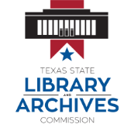
2.0.4 Internet Basics and Cyber Safety Resources
Help Using the Internet
- Internet Basics
Surfing Safety
- Internet Safety
- Password Meter
- Managing your online profile
- FBI’s Cybercrime Site
- Facebook Safety
- Banking Online
- Tips for Safe and Healthy Online Dating

